WEEK 5
QUESTION 1:
Write a program that prints a simple chessboard. Input format: The first line contains the number of inputs T. The lines after that contain a different values for size of the chessboard Output format: Print a chessboard of dimensions size * size. Print a Print W for white spaces and B for black spaces.
Input: 2 3 5
Output: WBW BWB WBW WBWBW BWBWB WBWBW BWBWB WBWBW
PROGRAM:
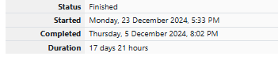
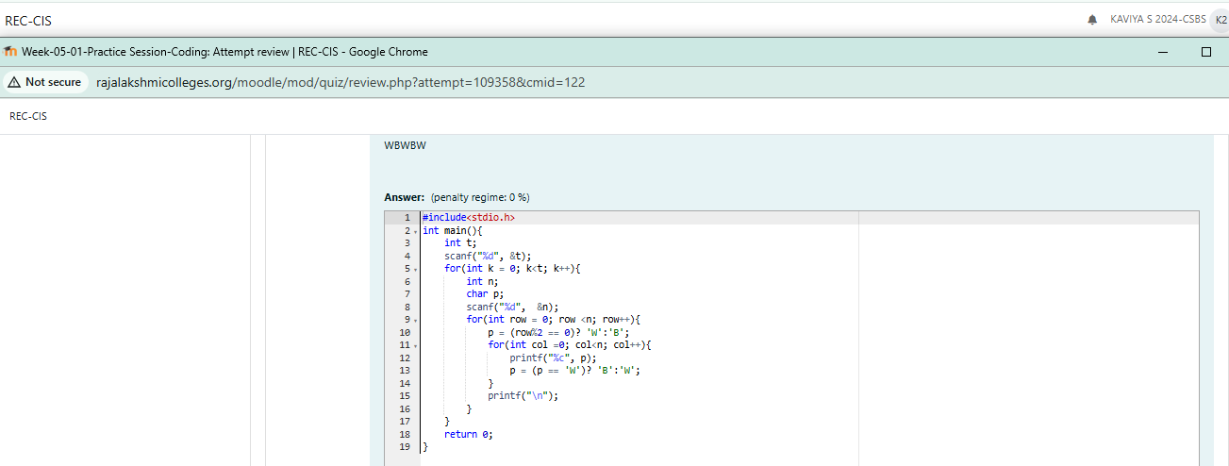
OUTPUT:
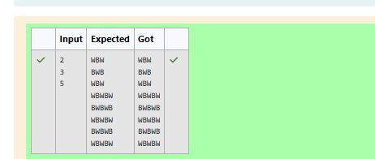
QUESTION 2:
Write a program that takes input:
The first line contains T, the number of test cases
Each test case contains an integer N and also the starting character of the chessboard
PROGRAM:

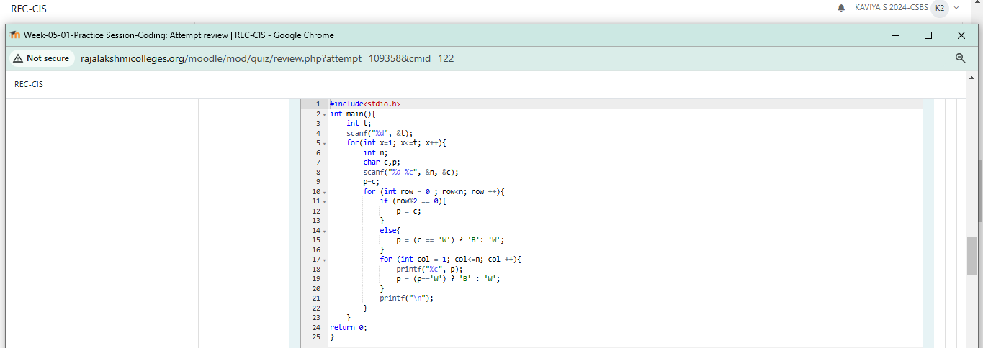
OUTPUT:
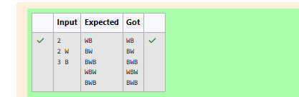
QUESTION 3:
Decode the logic and print the Pattern that corresponds to given input. If N= 3 then pattern will be : 10203010011012 **4050809 ****607 If N= 4, then pattern will be: 1020304017018019020 **50607014015016 ****809012013 ******10011
Constraints 2 <= N <= 100
Input Format First line contains T, the number of test cases Each test case contains a single integer N Output First line print Case #i where i is the test case number In the subsequent line, print the pattern Test Case 1 3 3 4 5 49
O u t p u t
C a s e # 1
1 0 2 0 3 0 1 0 0 1 1 0 1 2 * * 4 0 5 0 8 0 9 * * * * 6 0 7
C a s e # 2
1 0 2 0 3 0 4 0 1 7 0 1 8 0 1 9 0 2 0 * * 5 0 6 0 7 0 1 4 0 1 5 0 1 6 * * * * 8 0 9 0 1 2 0 1 3 * * * * * * 1 0 0 1 1
C a s e # 3
1 0 2 0 3 0 4 0 5 0 2 6 0 2 7 0 2 8 0 2 9 0 3 0 * * 6 0 7 0 8 0 9 0 2 2 0 2 3 0 2 4 0 2 5 * * * * 1 0 0 1 1 0 1 2 0 1 9 0 2 0 0 2 1 * * * * * * 1 3 0 1 4 0 1 7 0 1 8 * * * * * * * * 1 5 0 1 6
PROGRAM:

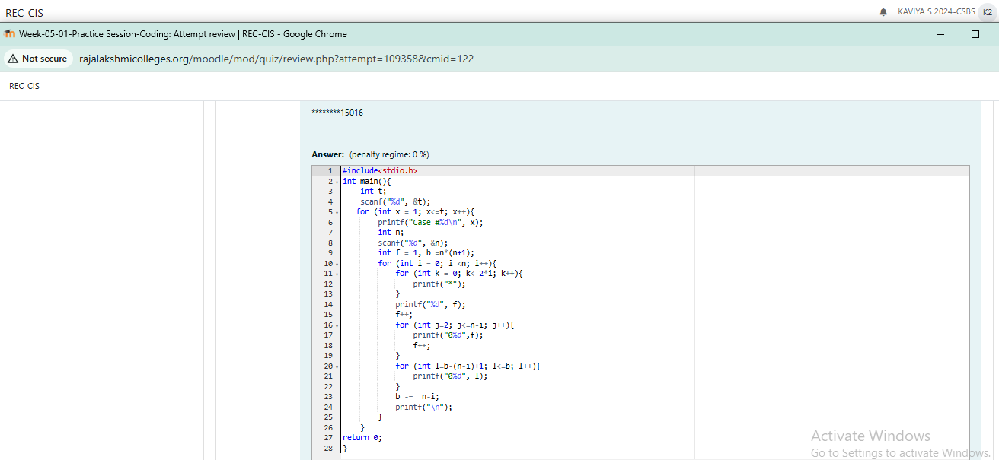

OUTPUT:
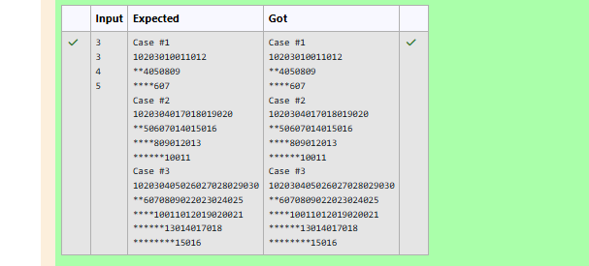
QUESTION 4:
The k-digit number N is an Armstrong number if and only if the k-th power of each digit sums to N. Given a positive integer N, return true if and only if it is an Armstrong number.
Example 1:
Input: 153
Output: true
PROGRAM:
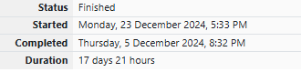
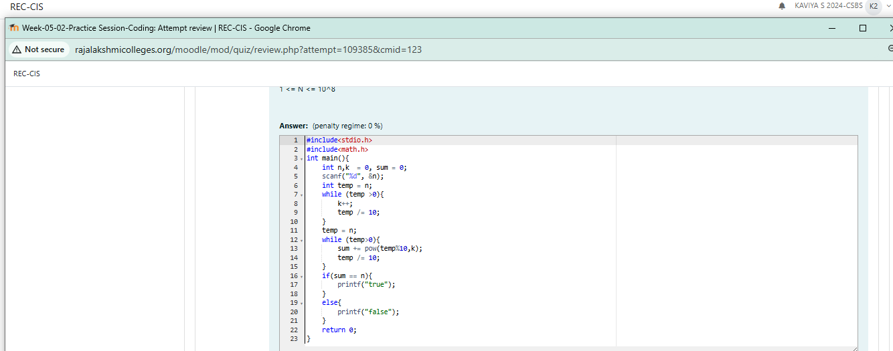
OUTPUT:
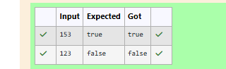
QUESTION 5:
Take a number, reverse it and add it to the original number until the obtained number is a palindrome. Constraints 1<=num<=99999999 Sample Input 1 32 Sample Output 1 55 Sample Input 2 789 Sample Output 2 66066
PROGRAM:

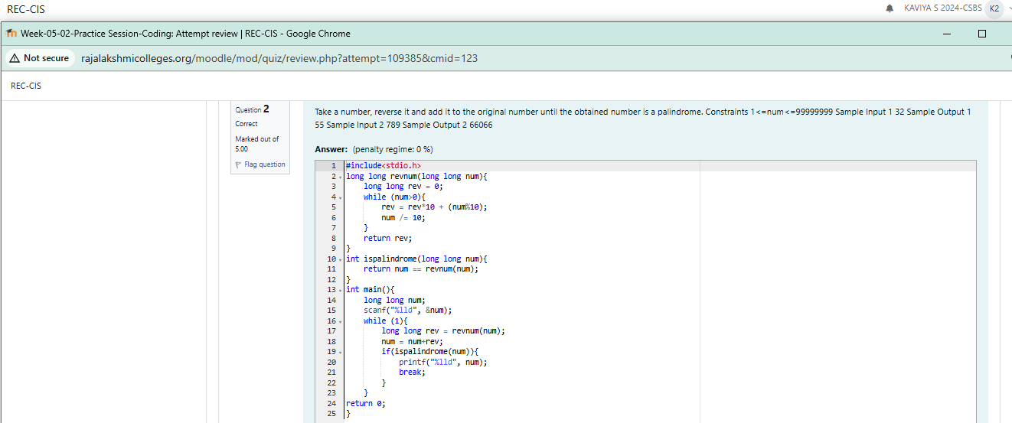

OUTPUT:
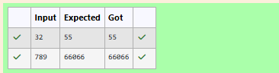
QUESTION 6:
A number is considered lucky if it contains either 3 or 4 or 3 and 4 both in it. Write a program to print the nth lucky number. Example, 1st lucky number is 3, and 2nd lucky number is 4 and 3rd lucky number is 33 and 4th lucky number is 34 and so on. Note that 13, 40 etc., are not lucky as they have other numbers in it. The program should accept a number 'n' as input and display the nth lucky number as output. Sample Input 1: 3
PROGRAM:

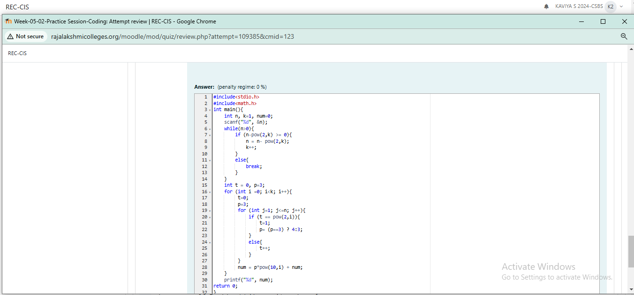
OUTPUT:
